AMAZON SALES DATA ANALYSIS
Business Analysis Report

Data Analyst Internship Project

Prepared By: Ayansh Singh
Organization: Innobyte Services
Report Date: July 4, 2026

Tools Used: Python (Pandas, Matplotlib) | SQL | Power BI

Table of Contents

2. Executive Summary 3
3. Problem Statement 4
4. Project Objectives 4
5. Business Understanding 5
6. Dataset Overview 6
7. Data Cleaning Process 8
8. Exploratory Data Analysis 10
9. SQL Analysis 21
10. Power BI Dashboard 23
11. Key Business Insights 25
12. Business Recommendations 26
13. Business Impact 27
14. Conclusion 27

2. Executive Summary
This report presents a comprehensive analysis of Amazon sales transaction data covering the period from March 2022 to June 2022. The analysis was conducted as part of a Data Analyst internship engagement and follows a structured workflow encompassing data cleaning, exploratory data analysis, SQL-based querying, and Power BI dashboard development.
The cleaned dataset consists of 128,579 transaction records across 24 fields, capturing order details, product attributes, fulfilment methods, and shipping geography. Analysis of this dataset shows total revenue of approximately ₹7.85 crore generated from 120,106 unique orders, with an average order value of ₹610.49 and total quantity sold of 116,330 units.
The business is heavily concentrated on a single sales channel (Amazon.in) and is predominantly B2C in nature. T-shirts and Shirts are the leading product categories by both revenue and quantity, while Medium, Large, and Extra Large sizes account for the largest share of demand. Maharashtra, Karnataka, and Tamil Nadu lead in state-level revenue contribution, with Bengaluru, Hyderabad, and Mumbai as the top revenue-generating cities.
The report concludes with a set of business recommendations focused on channel diversification, inventory prioritization, cancellation reduction, and regional marketing investment, supported directly by the findings from the SQL analysis, exploratory data analysis, and the Power BI dashboard.

3. Problem Statement
Analyze and provide insights on the Amazon Sales Report. The dataset contains information about Amazon sales transactions, including order ID, date, status, fulfilment method, sales channel, product category, size, quantity, amount, and shipping details. The objective of the project is to perform a comprehensive analysis of this data and extract actionable insights to support business decision-making.
The project was assigned with a defined completion timeline of 25 days and required the production of a full analytical workflow, from raw data inspection through to a business-ready Power BI dashboard.

4. Project Objectives
- Sales Overview: Analyze overall sales trends and patterns over time.
- Product Analysis: Identify popular product categories, sizes, and quantities.
- Fulfilment Analysis: Evaluate the effectiveness of fulfilment methods.
- Customer Segmentation: Segment customers based on behavior and location.
- Geographical Analysis: Study sales distribution across regions.
- Business Insights: Provide actionable recommendations for growth.

Deliverables
- Comprehensive analysis report with findings and recommendations.
- Visualizations including charts and graphs.
- Insights on product preferences and customer behavior.
- Recommendations for improving sales, inventory, and customer service.

5. Business Understanding
Amazon operates as a large-scale e-commerce marketplace connecting sellers with customers across India. The seller represented in this dataset primarily lists apparel products such as T-shirts, Shirts, Blazers, and Trousers, fulfilled either directly through Amazon's own logistics network or through the seller's own merchant-managed fulfilment (Easy Ship).
In this business model, revenue depends on order volume, average order value, and successful order completion. Cancellations and unshipped orders directly reduce realized revenue, while fulfilment method and shipping geography influence delivery speed and operating cost. Understanding these dynamics is central to identifying where the business can reduce leakage and where it can invest to grow.
The scope of this analysis is limited strictly to the transactional data provided; no external market or competitor data was used, and all findings are grounded in the uploaded dataset, notebooks, SQL queries, and dashboard.

6. Dataset Overview
The source dataset was an Amazon Sale Report export containing 128,976 records across 21 columns prior to cleaning. Following data quality assessment and cleaning (detailed in Section 7), the final analytical dataset used for EDA, SQL analysis, and dashboard development contains 128,579 records and 24 columns.
Metric | Value
Records (raw) | 128,976
Columns (raw) | 21
Records (cleaned) | 128,579
Columns (cleaned) | 24
Time period covered | March 2022 - June 2022
Currency | INR (Indian Rupees)

6.1 Data Dictionary
Field | Data Type | Business Description
order_id | Text | Unique identifier for each customer order
date | Date | Date on which the order was placed
status | Text | Detailed order status (e.g., Shipped, Cancelled, Pending)
fulfilment | Text | Party fulfilling the order: Amazon or Merchant
sales_channel | Text | Channel through which the sale occurred (Amazon.in / Non-Amazon)
ship_service_level | Text | Shipping speed tier: Standard or Expedited
category | Text | Product category (e.g., T-shirt, Shirt, Blazer, Trousers)
size | Text | Product size (e.g., S, M, L, XL, XXL)
courier_status | Text | Courier-level shipment status (Shipped, Unshipped, On the Way, Cancelled)
qty | Integer | Quantity of units ordered
currency | Text | Transaction currency (INR)
amount | Decimal | Order value in Indian Rupees
ship_city | Text | Customer shipping city
ship_state | Text | Customer shipping state
ship_postal_code | Numeric | Customer shipping postal code
ship_country | Text | Customer shipping country
b2b | Boolean | Indicates whether the order is a business (B2B) transaction
fulfilled_by | Text | Logistics operator: Amazon or Easy Ship
year | Integer | Order year (engineered)
month | Text | Order month name (engineered)
month_number | Integer | Order month number (engineered)
day | Integer | Order day of month (engineered)
day_name | Text | Order day of week (engineered)
quarter | Integer | Order quarter (engineered)

6.2 Business Importance of Key Fields
- amount and qty form the basis of all revenue and volume calculations, and are therefore the most business-critical fields in the dataset.
- status and courier_status jointly determine whether revenue is realized or lost to cancellation, and identify operational bottlenecks in the fulfilment chain.
- category and size drive product and inventory planning decisions.
- ship_state and ship_city enable geographic demand analysis and regional resource allocation.
- fulfilment and fulfilled_by indicate logistics dependency and are relevant to evaluating operational risk.
- b2b distinguishes business customers from individual consumers, supporting customer segmentation.
- The engineered date fields (year, month, quarter, day_name) enable time-based trend analysis without repeated date parsing.

7. Data Cleaning Process
The raw dataset required structured cleaning before it could support reliable analysis. Column names were first standardized to lowercase, underscore-separated format for consistency across Python, SQL, and Power BI. The cleaning steps below were performed in the Data Inspection & Cleaning notebook and are summarized in order of execution.

7.1 Missing Values
A missing value assessment was performed across all columns. The table below summarizes the fields that contained missing data and the treatment applied to each.
Field | Missing Count | Missing % | Treatment Applied
pendings | 128,976 | 100.00% | Column dropped - entirely empty and not relevant to analysis
new | 128,976 | 100.00% | Column dropped - entirely empty and not relevant to analysis
fulfilled_by | 89,713 | 69.56% | Filled with "Amazon" - missing values corresponded to Amazon-fulfilled orders
currency | 7,800 | 6.05% | Filled with "INR", the only currency present in the dataset
amount | 7,800 | 6.05% | Rows with a genuine cancellation retained with amount set to 0; 229 non-cancelled rows with missing amount and no reliable value removed
ship_state / ship_city / ship_country | 35 each | 0.03% | Filled with "Unknown" to preserve the order record
ship_postal_code | 35 | 0.03% | Filled with 0 and converted to integer type

7.2 Duplicate Handling
A duplicate check identified 168 fully duplicated records. These were removed using drop_duplicates(). A post-cleaning duplicate check confirmed zero remaining duplicate records in the final dataset.

7.3 Data Type Conversion
- The date column, originally stored as inconsistent text, was converted to a proper datetime type using a mixed-format parser.
- ship_postal_code was converted from a floating-point type to integer after filling missing values.

7.4 Feature Engineering
Six new time-based fields were derived from the cleaned date column to support trend analysis without repeated parsing during EDA, SQL, and Power BI work:
- year - calendar year of the order
- month - full month name
- month_number - numeric month (1-12) for correct chronological sorting
- day - calendar day of month
- day_name - day of week
- quarter - calendar quarter

7.5 Standardization
Column names were standardized (stripped, lower-cased, spaces and hyphens replaced with underscores) to ensure consistent references across the Python, SQL, and Power BI layers of the project. Currency was standardized to a single value (INR) across all records.

7.6 Final Cleaned Dataset Summary
Attribute | Value
Final row count | 128,579
Final column count | 24
Duplicate records | 0
Missing values remaining | 0
Date field type | datetime64
Output file | Amazon_Sales_Cleaned.csv

8. Exploratory Data Analysis
Exploratory Data Analysis (EDA) was performed on the cleaned dataset to identify sales trends, product performance, fulfilment efficiency, customer behavior, and geographical distribution. Each analysis below reflects the calculations and visualizations produced in the Exploratory Data Analysis notebook.

8.1 Business Overview
Metric | Value
Total Orders | 120,106
Total Revenue | ₹78,496,786.39
Total Quantity Sold | 116,330
Average Order Value | ₹610.49
This summary establishes the baseline scale of the business and serves as the reference point for all subsequent segment-level analysis.

8.2 Sales Trend Analysis
Month | Total Revenue (₹) | Total Orders
March | 101,683.85 | 158
April | 28,742,816.41 | 45,657
May | 26,226,476.75 | 39,180
June | 23,425,809.38 | 35,111
March reflects a partial month with minimal activity, indicating the effective start of full-scale operations in April. Revenue and order volume both peaked in April and declined progressively through May and June, a pattern that should inform demand forecasting, inventory planning, and the timing of promotional campaigns for future periods.
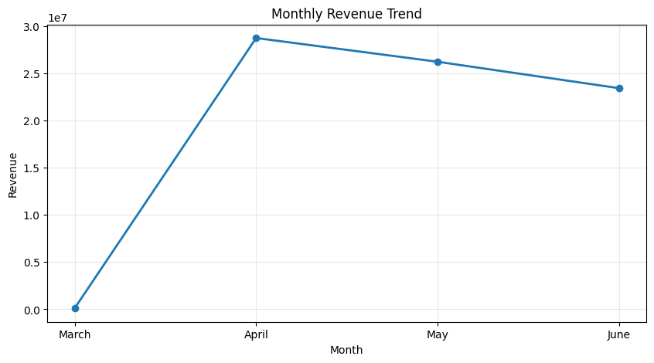
Figure 8.2.1 - Monthly Revenue Trend

8.3 Order Status Analysis
Status | Orders | Revenue (₹)
Shipped | 72,627 | 50,268,420.00
Shipped - Delivered to Buyer | 26,521 | 18,619,610.00
Cancelled | 17,166 | 6,910,831.39
Shipped - Returned to Seller | 1,850 | 1,269,245.00
Shipped - Picked Up | 918 | 661,252.00
Pending | 584 | 430,271.00
Pending - Waiting for Pick Up | 262 | 192,138.00
Shipped - Returning to Seller | 130 | 107,620.00
Shipped - Out for Delivery | 32 | 26,971.00
Shipped - Rejected by Buyer | 11 | 729.00
The large majority of orders reach a shipped or delivered state, indicating a broadly efficient fulfilment process. Cancellations represent the second-largest status group by order count, making cancellation reduction a meaningful lever for revenue recovery.
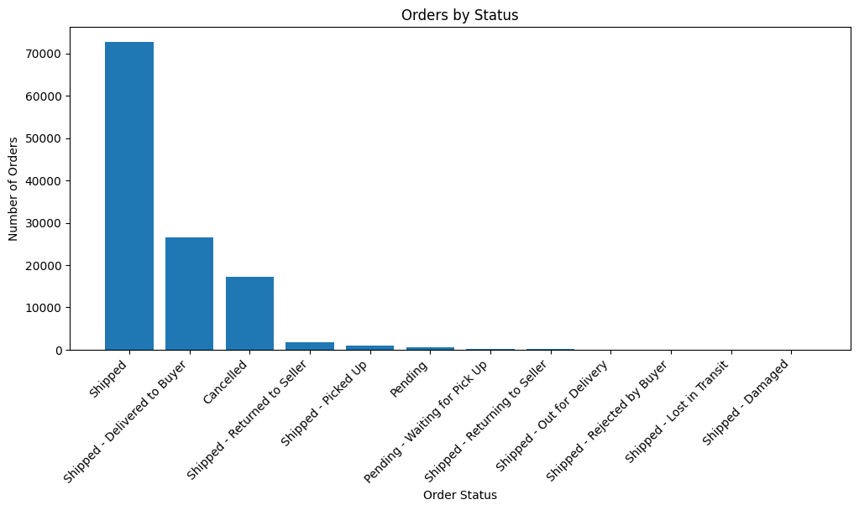
Figure 8.3.1 - Orders by Status

8.4 Product Category Analysis
Category | Orders | Quantity | Revenue (₹)
T-shirt | 47,718 | 45,165 | 39,154,132.17
Shirt | 46,438 | 44,903 | 21,269,768.70
Blazzer | 14,977 | 13,930 | 11,208,506.12
Trousers | 10,136 | 9,885 | 5,341,305.30
Perfume | 1,146 | 1,051 | 789,419.66
Wallet | 893 | 844 | 458,408.18
Socks | 408 | 397 | 150,397.50
Shoes | 144 | 152 | 123,933.76
Watch | 2 | 3 | 915.00
T-shirts and Shirts jointly account for the majority of both revenue and quantity sold, confirming apparel as the core product line. Blazers generate disproportionately higher revenue relative to their order volume, indicating a higher average selling price within that category. Smaller categories such as Perfume, Wallet, Socks, Shoes, and Watch contribute marginally and appear incidental rather than core to the catalogue.
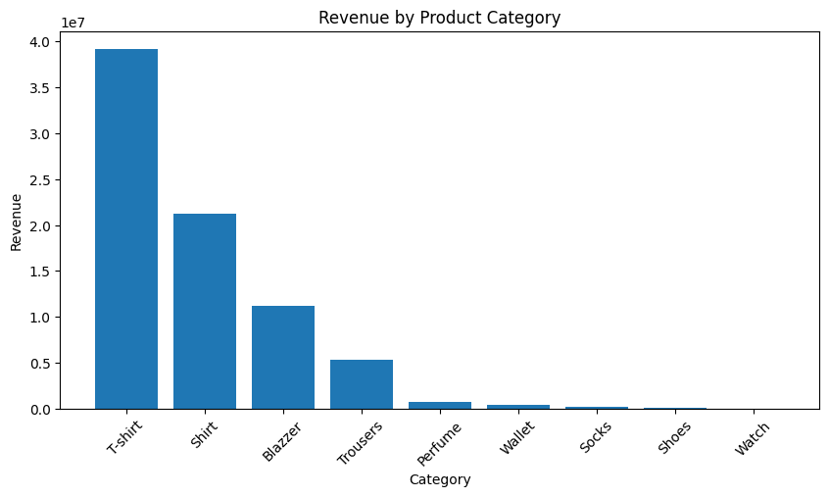
Figure 8.4.1 - Revenue by Product Category
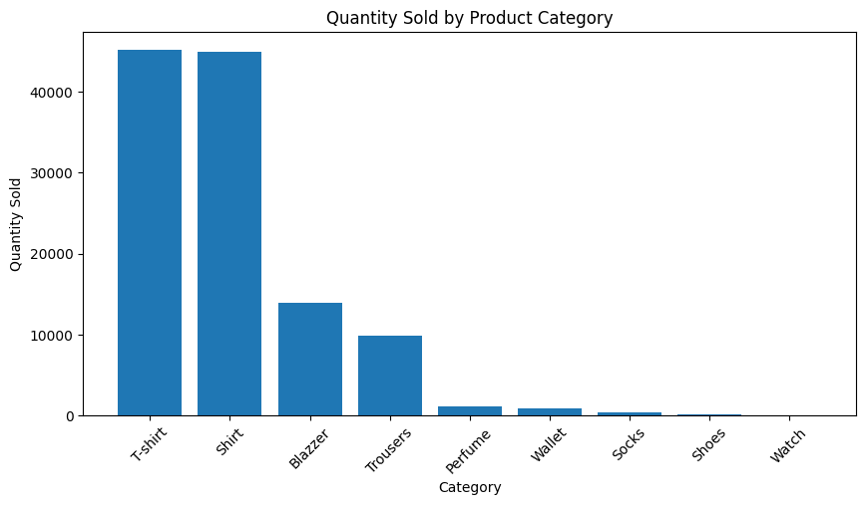
Figure 8.4.2 - Quantity Sold by Product Category

8.5 Product Size Analysis
Size | Orders | Quantity | Revenue (₹)
M | 21,364 | 20,096 | 13,678,295.13
L | 20,698 | 19,652 | 13,023,938.84
XL | 19,537 | 18,587 | 12,240,095.38
XXL | 16,860 | 16,201 | 10,452,621.64
S | 16,002 | 15,004 | 10,414,943.18
3XL | 13,571 | 13,328 | 9,026,104.92
XS | 10,400 | 9,815 | 6,952,253.10
Free | 2,185 | 2,050 | 1,372,676.60
6XL | 680 | 687 | 576,249.33
5XL | 525 | 512 | 425,156.63
4XL | 394 | 398 | 334,451.64
Medium, Large, and Extra Large sizes account for the largest share of both orders and revenue, reflecting the core size range of the customer base. Extended sizes (4XL-6XL) represent a small proportion of demand and should be stocked more conservatively relative to core sizes.
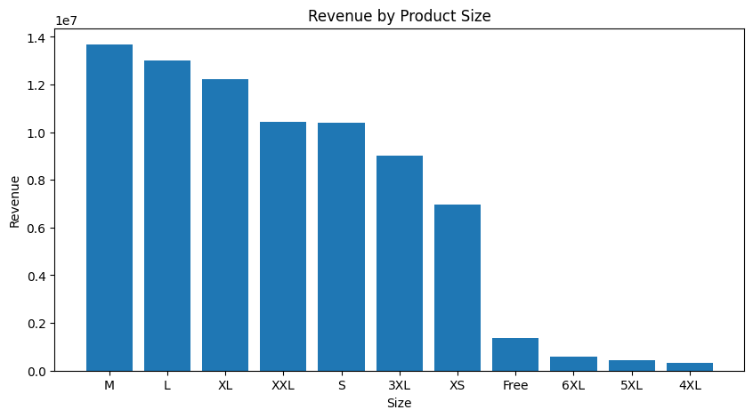
Figure 8.5.1 - Revenue by Product Size
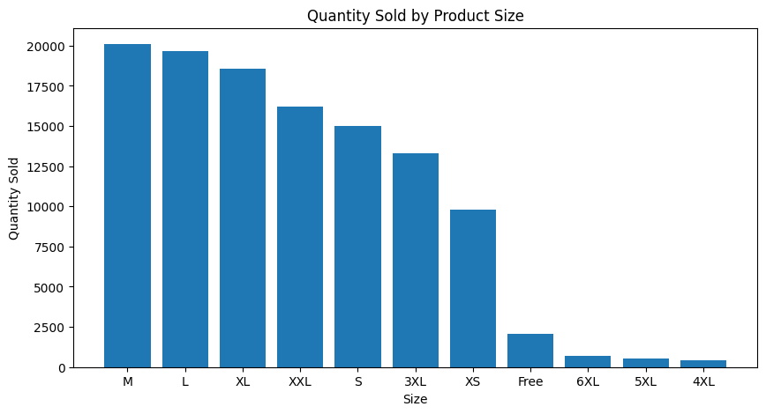
Figure 8.5.2 - Quantity Sold by Product Size

8.6 Fulfilment Analysis
Fulfilment | Orders | Revenue (₹)
Amazon | 83,783 | 54,262,165.00
Merchant | 36,323 | 24,234,621.39
Amazon-managed fulfilment handles the larger share of both order volume and revenue, reflecting strong reliance on Amazon's logistics network. Merchant-managed fulfilment (Easy Ship) represents a meaningful secondary channel and can be benchmarked separately for delivery performance.
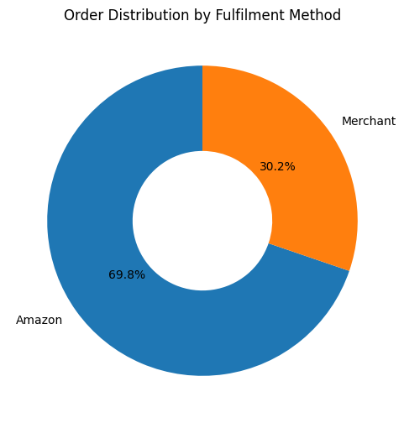
Figure 8.6.1 - Order Distribution by Fulfilment Method

8.7 Sales Channel Analysis
Sales Channel | Orders | Revenue (₹)
Amazon.in | 120,105 | 78,496,786.39
Non-Amazon | 1 | 0.00
Amazon.in is effectively the sole sales channel, accounting for 120,105 of 120,106 total orders and the entirety of recorded revenue. This represents a significant channel concentration risk, as the business has almost no diversification away from a single third-party marketplace.
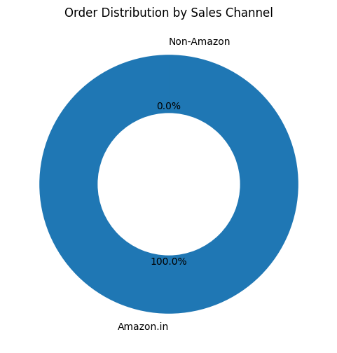
Figure 8.7.1 - Order Distribution by Sales Channel

8.8 Courier Status Analysis
Courier Status | Orders | Revenue (₹)
Shipped | 102,102 | 70,971,225.00
On the Way | 6,375 | 3,185,870.39
Unshipped | 6,066 | 4,339,691.00
Cancelled | 5,573 | 0.00
The majority of orders are successfully shipped at the courier level, consistent with the order status findings above. Unshipped orders, which still carry ₹4.3 million in associated order value, represent an operational area worth investigating to recover otherwise-lost fulfilment.
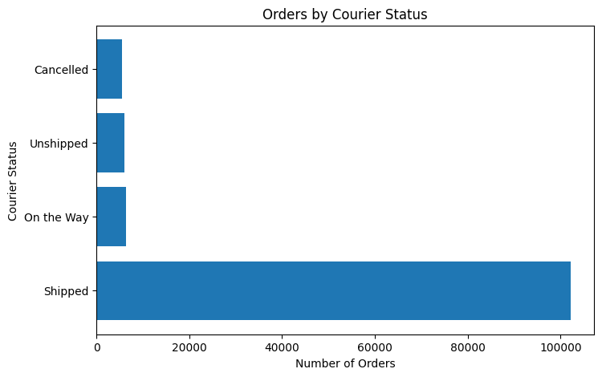
Figure 8.8.1 - Orders by Courier Status

8.9 B2B vs B2C Analysis
Customer Type | Orders | Revenue (₹)
B2C | 119,312 | 77,905,565.60
B2B | 794 | 591,220.79
The customer base is overwhelmingly B2C, with B2B transactions contributing less than one percent of total orders and revenue. This confirms the business currently operates primarily as a direct-to-consumer apparel seller, with corporate and bulk sales representing an underdeveloped channel.
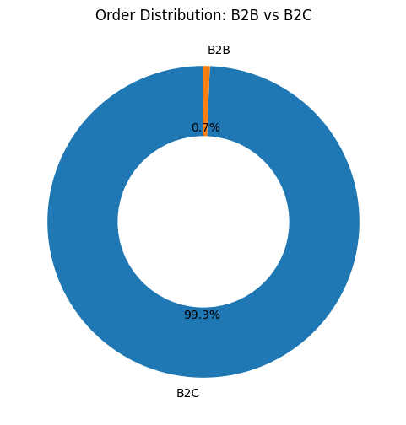
Figure 8.9.1 - Order Distribution: B2B vs B2C

8.10 Top 10 States by Revenue
State | Orders | Revenue (₹)
Maharashtra | 20,756 | 13,318,966.38
Karnataka | 16,162 | 10,465,387.03
Telangana | 10,394 | 6,909,670.08
Uttar Pradesh | 10,057 | 6,814,126.08
Tamil Nadu | 10,507 | 6,510,503.73
Delhi | 6,347 | 4,228,503.97
Kerala | 6,097 | 3,821,997.58
West Bengal | 5,645 | 3,503,223.44
Andhra Pradesh | 4,970 | 3,214,859.86
Haryana | 4,134 | 2,879,146.99
Maharashtra, Karnataka, and Tamil Nadu are the highest revenue-generating states, together contributing a substantial share of total revenue. These states represent priority markets for inventory allocation, regional marketing, and delivery investment.
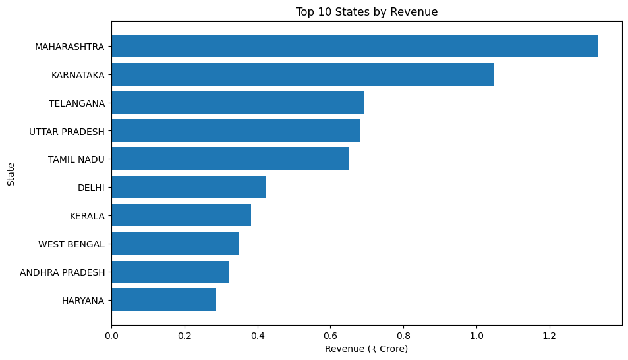
Figure 8.10.1 - Top 10 States by Revenue (₹ Crore)

8.11 Top 10 Cities by Revenue
City | Orders | Revenue (₹)
Bengaluru | 10,441 | 6,836,614.65
Hyderabad | 7,404 | 4,941,790.25
Mumbai | 5,645 | 3,696,704.04
New Delhi | 5,425 | 3,608,277.78
Chennai | 4,925 | 3,098,745.74
Pune | 3,593 | 2,337,978.18
Kolkata | 2,246 | 1,412,815.87
Gurugram | 1,768 | 1,220,562.74
Thane | 1,612 | 1,003,878.29
Lucknow | 1,393 | 933,926.34
Metropolitan cities, led by Bengaluru, Hyderabad, and Mumbai, contribute a disproportionately large share of revenue relative to their share of total geography, confirming urban markets as the primary revenue engine.

8.12 Revenue Distribution Analysis
A histogram of order amounts (for orders up to ₹2,000) shows that the large majority of transactions cluster within a moderate value range, consistent with the ₹610.49 average order value calculated in the business overview. This indicates that revenue growth is driven primarily by order volume rather than a small number of high-value transactions.
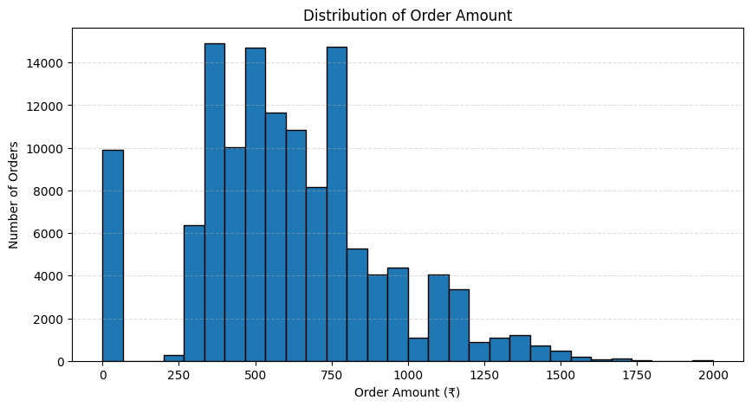
Figure 8.12.1 - Distribution of Order Amount

8.13 Monthly Order Trend
Month | Orders
March | 158
April | 45,657
May | 39,180
June | 35,111
The monthly order trend mirrors the revenue trend, with order volume peaking in April and declining through May and June. This consistent pattern across both orders and revenue strengthens confidence that the decline reflects a genuine demand shift rather than a change in average pricing.
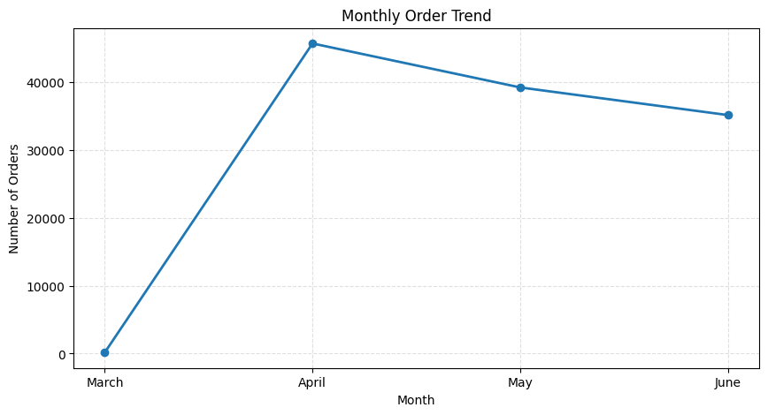
Figure 8.13.1 - Monthly Order Trend

8.14 Top Products by Quantity Sold
Ranked by total quantity sold, T-shirts (45,165 units) and Shirts (44,903 units) are the clear leaders, followed by Blazers (13,930 units) and Trousers (9,885 units). This ranking is consistent with the revenue-based category ranking in Section 8.4, confirming that the top categories are driven by genuine volume demand rather than price alone.
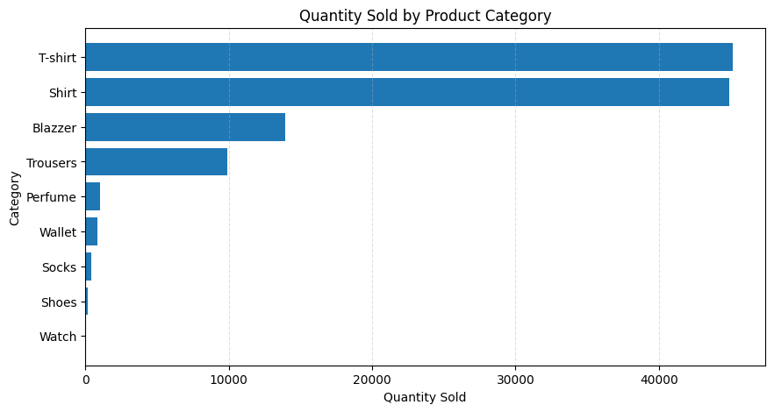
Figure 8.14.1 - Quantity Sold by Product Category (Ranked)

8.15 EDA Conclusion
The exploratory data analysis provided a comprehensive view of Amazon's sales performance, customer purchasing patterns, product demand, fulfilment efficiency, and geographical distribution. Key findings include heavy reliance on a single sales channel, dominance of apparel categories, concentration of demand in core sizes, and strong performance from major urban markets, alongside a meaningful cancellation rate that represents an area for operational improvement.

9. SQL Analysis
A relational schema (amazon_sales) was defined to mirror the cleaned dataset, and a series of SQL queries were written to reproduce and validate the key metrics used throughout this report. SQL analysis serves as an independent, auditable layer of validation for the findings surfaced in the Python-based EDA and provides the query logic that also underpins the Power BI dashboard. The table below summarizes the purpose and business significance of each query.
Query | Logic Used | Business Significance
Total Orders | COUNT(DISTINCT order_id) | Establishes the total number of unique customer orders as the baseline volume metric.
Total Revenue | SUM(amount) | Calculates total revenue generated across all transactions.
Average Order Value | AVG(amount) | Measures typical transaction size, a key input for pricing and promotion strategy.
Total Quantity Sold | SUM(qty) | Quantifies total unit volume moved, distinct from revenue.
Monthly Revenue | GROUP BY month_number, month | Tracks revenue over time to identify seasonality and growth or decline trends.
Monthly Orders | GROUP BY month_number, month | Tracks order volume over time, complementing the revenue trend.
Revenue by Product Category | GROUP BY category | Identifies which product categories drive the most revenue.
Quantity Sold by Category | GROUP BY category | Identifies which categories drive the most unit volume, independent of price.
Revenue by Product Size | GROUP BY size | Determines which sizes generate the most revenue, informing size-level inventory decisions.
Orders by Order Status | GROUP BY status | Breaks down orders by final status to quantify shipped, cancelled, and pending volumes.
Orders by Courier Status | GROUP BY courier_status | Evaluates shipment-level performance separately from order-level status.
Orders by Fulfilment Method | GROUP BY fulfilment | Compares Amazon-managed versus merchant-managed fulfilment on volume and revenue.
B2B vs B2C Analysis | CASE WHEN b2b | Segments transactions by customer type to quantify the B2B opportunity.
Top 10 States by Revenue | GROUP BY ship_state, LIMIT 10 | Ranks states to prioritize regional investment.
Top 10 Cities by Revenue | GROUP BY ship_city, LIMIT 10 | Ranks cities to identify the strongest urban markets.
Revenue by Sales Channel | GROUP BY sales_channel | Quantifies channel concentration risk.
Revenue by Fulfilled By | GROUP BY fulfilled_by | Compares Amazon logistics versus Easy Ship on order volume and revenue.
Top 10 Highest Revenue Orders | ORDER BY amount DESC, LIMIT 10 | Identifies the largest individual transactions for outlier review.
Average Revenue by State | AVG(amount), GROUP BY ship_state | Measures typical order value by region, independent of order count.
Monthly Revenue by Category | GROUP BY month, category | Cross-tabulates time and category to detect seasonal category shifts.
Top 5 States by Quantity Sold | SUM(qty), GROUP BY ship_state, LIMIT 5 | Ranks states by unit volume rather than revenue, useful for logistics planning.
Revenue by Ship Service Level | GROUP BY ship_service_level | Compares Standard versus Expedited shipping on order volume and revenue.
Cancelled Orders Percentage | COUNT(CASE WHEN status = 'Cancelled') | Quantifies the cancellation rate as a single operational KPI.
Revenue by Quarter | GROUP BY quarter | Aggregates revenue at the quarterly level for higher-level trend reporting.
Top 5 Revenue Generating Days | GROUP BY day_name, LIMIT 5 | Identifies which days of the week generate the most revenue.

Collectively, these queries validate the core findings from the exploratory analysis: heavy dependence on the Amazon.in channel, apparel category dominance, moderate order values, and concentrated demand in a small number of leading states and cities. The SQL layer also isolates specific operational KPIs, such as the cancelled order percentage, that are used directly as dashboard metrics.

10. Power BI Dashboard
A single-page interactive Power BI dashboard (Amazon_Sales_Dashboard.pbix) was developed to present the key findings from the SQL and EDA analysis in a business-facing, self-service format. The dashboard screenshot is shown below, followed by a breakdown of its components.
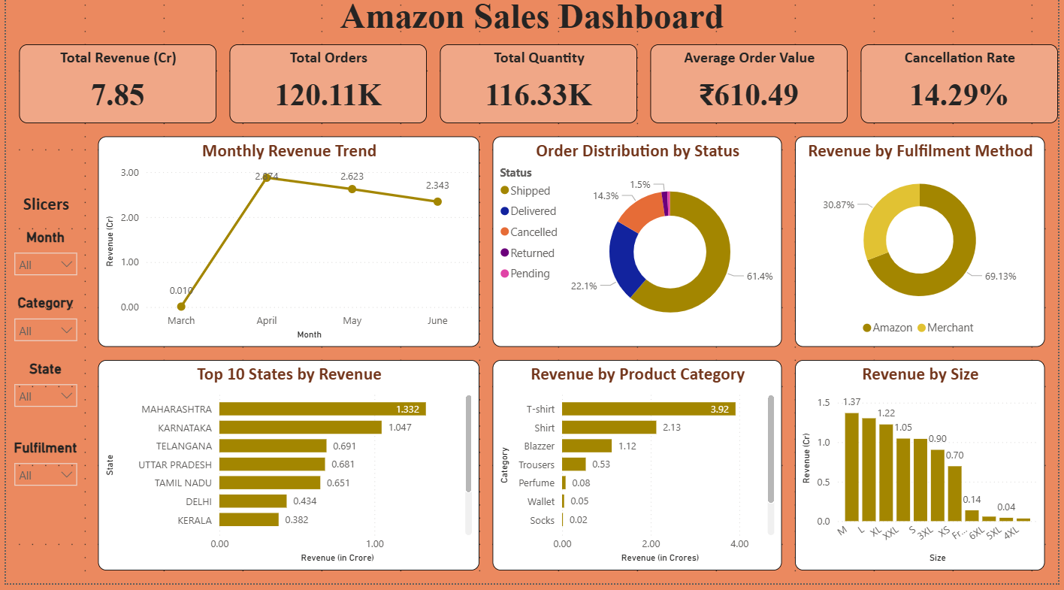

10.1 Key Performance Indicators
KPI Card | Value Displayed | Business Purpose
Total Revenue (Cr) | 7.85 | Headline revenue figure in crore rupees for at-a-glance reporting
Total Orders | 120.11K | Total unique order volume
Total Quantity | 116.33K | Total units sold, distinct from order count
Average Order Value | ₹610.49 | Typical transaction size
Cancellation Rate | 14.29% | Share of orders cancelled, a core operational efficiency metric

10.2 Visualizations
- Monthly Revenue Trend (line chart): Plots revenue across March-June, visually confirming the April peak and subsequent decline identified in the EDA.
- Order Distribution by Status (donut chart): Breaks down orders into Shipped (61.4%), Delivered (22.1%), Cancelled (14.3%), Returned (1.5%), and Pending, giving an immediate read on fulfilment health.
- Revenue by Fulfilment Method (donut chart): Splits revenue between Amazon (69.13%) and Merchant (30.87%) fulfilment.
- Top 10 States by Revenue (bar chart): Ranks states from Maharashtra down to Kerala, supporting regional prioritization decisions.
- Revenue by Product Category (bar chart): Ranks categories from T-shirt down to Socks, reinforcing apparel as the primary revenue driver.
- Revenue by Size (bar chart): Ranks sizes from M down to 4XL, supporting size-level inventory planning.

10.3 Slicers
- Month: Filters all visuals to a selected month for period-specific review.
- Category: Filters all visuals to a selected product category.
- State: Filters all visuals to a selected shipping state.
- Fulfilment: Filters all visuals to a selected fulfilment method (Amazon or Merchant).

10.4 Dashboard Design
The dashboard uses a single consistent color palette (dark gold and warm orange) against a light background, with all KPI cards aligned along the top of the page and detail visuals arranged in a three-column grid below. Slicers are grouped on the left panel, allowing users to filter the entire page without needing to navigate multiple report pages. This single-page, slicer-driven layout is designed for quick executive review rather than deep multi-page exploration.

10.5 Business Value
The dashboard translates the SQL and EDA findings into a reusable, interactive tool that business stakeholders can filter and explore without needing to run code or queries themselves. It surfaces the same core findings as this report, revenue concentration in a single channel, apparel category dominance, moderate cancellation rates, and geographic concentration, in a format suitable for ongoing operational monitoring rather than a one-time analysis.

11. Key Business Insights
- Amazon.in generated nearly all orders and revenue, indicating that the business is highly dependent on a single sales channel.
- Amazon Fulfilment handled the majority of customer orders, demonstrating strong reliance on Amazon's logistics network.
- T-Shirts and Shirts emerged as the top-performing product categories in terms of both revenue and quantity sold.
- Medium (M), Large (L), and Extra Large (XL) sizes recorded the highest sales, reflecting customer preference for these sizes.
- Maharashtra, Karnataka, and Tamil Nadu were among the highest revenue-generating states, indicating strong demand in these regions.
- Metropolitan cities such as Bengaluru, Hyderabad, Mumbai, Chennai, and New Delhi contributed a significant share of total revenue.
- Most orders were successfully shipped or delivered, indicating an efficient order fulfillment process with relatively fewer cancelled or pending orders.
- The customer base is predominantly B2C, while B2B orders account for only a small percentage of total transactions.
- The majority of customer purchases fall within a moderate price range, with only a few high-value transactions contributing to overall revenue.
- Monthly sales trends show fluctuations in customer demand, highlighting the importance of seasonal planning for inventory and promotional campaigns.

12. Business Recommendations
- Reduce dependency on Amazon.in by expanding sales through additional online marketplaces and the company's own website.
- Maintain adequate inventory levels for high-performing product categories such as T-Shirts and Shirts to prevent stock shortages.
- Prioritize inventory for Medium, Large, and XL sizes, as they consistently generate higher customer demand.
- Increase marketing efforts in top-performing states and metropolitan cities to maximize revenue and customer acquisition.
- Investigate the primary causes of cancelled and pending orders to improve customer satisfaction and operational efficiency.
- Strengthen logistics and delivery performance in regions with comparatively lower shipment success rates.
- Develop targeted promotional campaigns during low-sales periods to improve monthly sales consistency.
- Explore opportunities to expand B2B partnerships and corporate sales to diversify the customer base.
- Analyze high-performing products regularly to optimize pricing, inventory management, and future product launches.
- Implement data-driven demand forecasting using historical sales trends to optimize inventory planning, minimize stock shortages, and reduce excess inventory.

13. Business Impact
Acting on the recommendations above would be expected to produce impact across three areas directly supported by the analysis:

Revenue Protection and Recovery
The cancellation rate of 14.29% and the 6,066 unshipped orders identified in the courier status analysis represent revenue that is at risk or already lost. Even a modest reduction in cancellations would recover a meaningful share of the ₹6.9 million currently associated with cancelled orders.

Inventory Efficiency
Aligning stock levels with the demonstrated demand concentration in T-shirts, Shirts, and the M/L/XL size range should reduce both stockouts on fast-moving items and excess inventory in low-demand categories and extended sizes, improving working capital efficiency.

Channel and Customer Diversification
Because Amazon.in accounts for effectively all recorded revenue, any disruption to that channel, such as a policy change, fee increase, or account-level issue, would materially affect the entire business. Diversifying into additional marketplaces, a direct website, and B2B sales would reduce this single point of failure over time.

14. Conclusion
The problem statement for this project was to analyze the Amazon Sales Report and provide insights on sales trends, product performance, fulfilment effectiveness, customer segmentation, and geographical distribution, in order to generate actionable recommendations for business decision-making. This analysis addresses that brief directly using the 128,579 cleaned transaction records.
On Sales Overview, the analysis shows total revenue of ₹7.85 crore from 120,106 orders at an average order value of ₹610.49, with a clear monthly pattern of an April peak followed by a decline through May and June. On Product Analysis, T-shirts and Shirts are confirmed as the leading categories by both revenue and quantity, with Medium, Large, and Extra Large the dominant sizes. On Fulfilment Analysis, Amazon-managed fulfilment handles the larger share of orders and revenue, while the order and courier status breakdowns quantify a 14.29% cancellation rate as the primary efficiency gap. On Customer Segmentation, the base is confirmed as overwhelmingly B2C, with B2B representing a small, distinct segment. On Geographical Analysis, Maharashtra, Karnataka, and Tamil Nadu, along with metropolitan cities such as Bengaluru, Hyderabad, and Mumbai, are identified as the strongest-performing markets.
Taken together, these findings satisfy each objective set out in the problem statement and support the Business Insights and Recommendations presented in Sections 11 and 12, which are intended to guide decisions on channel strategy, inventory planning, and operational improvement going forward.

